State of Florida vs. John Smith, Defendant
Case #: 2015 BR 012416 AX
Charge: 33-119 (“Parking in Space Provided for Disabled”)

MOTION FOR DISMISSAL

Background

On October 5 at 6:13 PM, Defendant was cited under Sarasota Code § 33-119 (“parked in a handicapped access space”) while his motorcycle was parked in front of 1453 Main Street in Sarasota, Florida. The fine for such an infraction is $250.00. Defendant contested the citation with the Parking Division, and now appeals their denial.

Parking Space Was Not Properly Marked

Sarasota Code § 33-119 is specifically pursuant to F.S. § 316.1955, which requires handicap parking spaces to be “specially designated and marked.” F.S. § 316.1955(1) requires handicap parking spaces to be marked in accordance with F.S. § 553.5041. The relevant sections § 553.5041 are as follows:

§ 553.5041(5)(c)1: Each parking space must be at least 12 feet wide. Parking access aisles must be at least 5 feet wide and must be part of an accessible route to the building or facility entrance. The access aisle must be striped diagonally to designate it as a no-parking zone.

§ 553.5041(6): Each such parking space must be striped in a manner that is consistent with the standards of the controlling jurisdiction for other spaces and prominently outlined with blue paint, and must be repainted when necessary, to be clearly distinguishable as a parking space designated for persons who have disabilities. The space must be posted with a permanent above-grade sign of a color and design approved by the Department of Transportation, which is placed on or at least 60 inches above the finished floor or ground surface measured to the bottom of the sign and which bears the international symbol of accessibility meeting the requirements of s. 703.7.2.1 of the standards and the caption “PARKING BY DISABLED PERMIT ONLY.” Such a sign erected after October 1, 1996, must indicate the penalty for illegal use of the space.

As shown in Exhibit A Photos 1 and 2, the parking space in question was not marked in a manner consistent with other spaces in Sarasota as required by F.S. § 553.5041(6). The parking space is not consistent with other handicap parking spaces in the City (see, e.g., Exhibit A Photos 7 – 8). In fact, the markings of the parking space in question are identical to those of several legal Sarasota motorcycle parking spaces (see, e.g., Exhibit A Photos 3 – 6).

As shown in Exhibit A Photos 1 and 2, the parking space in question was not prominently outlined with blue paint as required by F.S. § 553.5041(6).

As shown in Exhibit A Photos 1 and 2, the parking space in question was not striped diagonally as required by F.S. § 553.5041(5)(c)(1). In turning down Defendant's 11/5/2015 appeal, the Parking Division in its Administrative Response noted only: “parked in handicap access aisle + area is striped.” However, as clearly shown by counterexample in Exhibit A Photos 3 – 6, striped areas do not reliably indicate a handicap access aisle in the City of Sarasota.

As shown in Exhibit A Photos 1 and 2, the parking space was not posted with an above-grade sign as required by F.S. § 553.5041(6). The City has marked some triangular spaces as being legal places to park (see, e.g., Exhibit A, Photos 3 – 6), while signage is lackingon the parking space in question. In essence, the City is using above-grade signs to mark non-handicapped spots, which is actually the opposite of what is required by F.S. § 553.5041(6).

In summary, the parking space in question does not comply with a single one of the 4 marking requirements of F.S. § 553.5041. As per F.S. § 316.1955(1), a violation is subject to dismissal if the space is not general compliance or is not clearly distinguishable as a designated accessible parking space for people who have disabilities. In the absence of proper marking, Section 1955 indicates that only a warning should have been issued, not a citation.

For the reasons indicated above, Defendant respectfully requests that this case be dismissed.

__________________________
John Smith, Defendant (pro se)

Dated January 2, 2015

EXHIBIT A

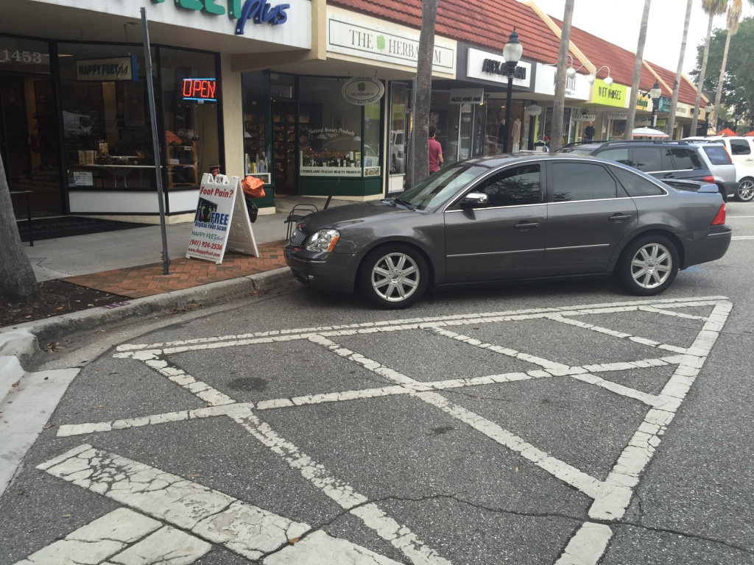
Photo 1: 1453 Main Street (parking space in question;
no blue lines as required by F.S. § 553.5041(6),
crosshatch pattern not in accordance with F.S. § 553.5041(5c1))

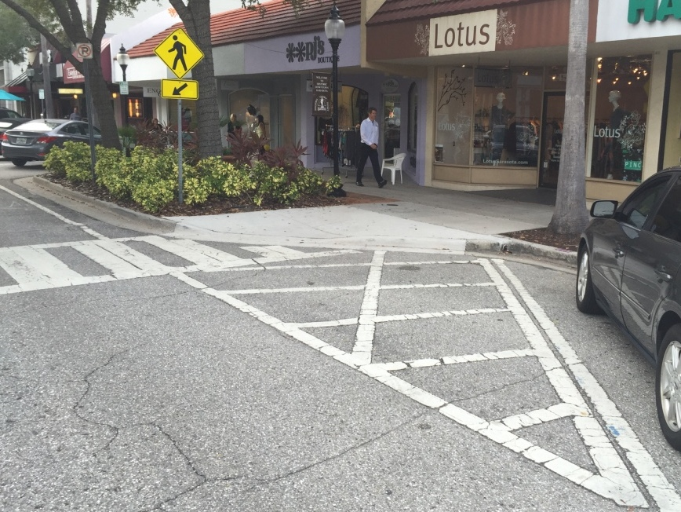
Photo 2: 1453 Main Street (parking space in question;
no above-grade sign as required by F.S. § 553.5041(6))

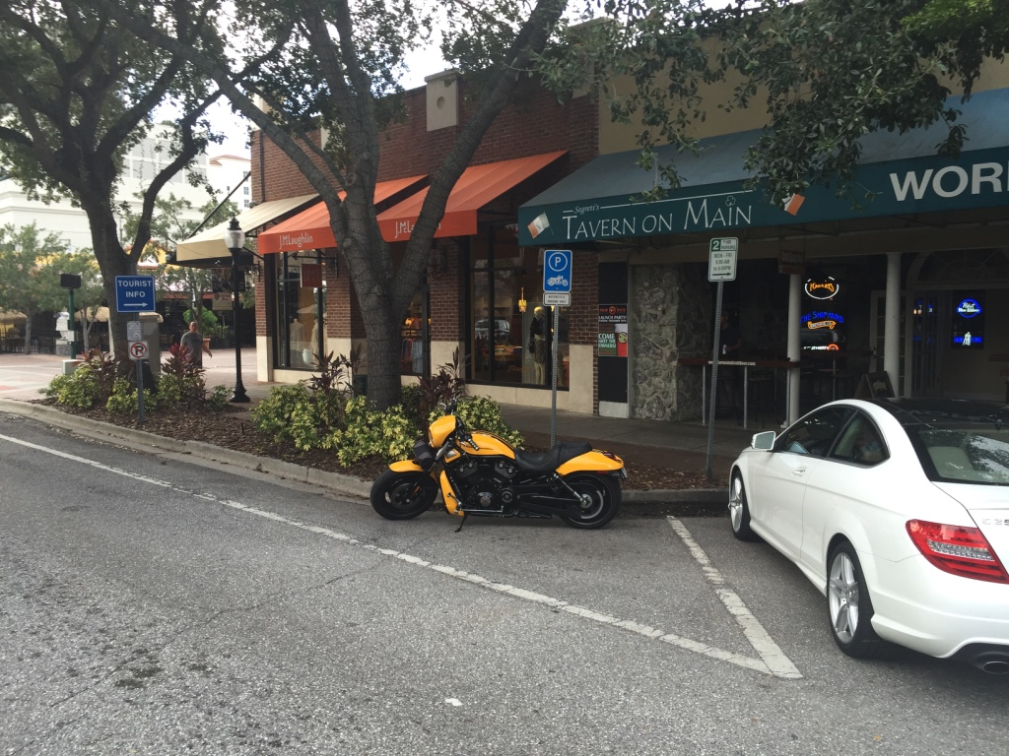
Photo 3: 1507 Main Street (legal parking space, no stripes)

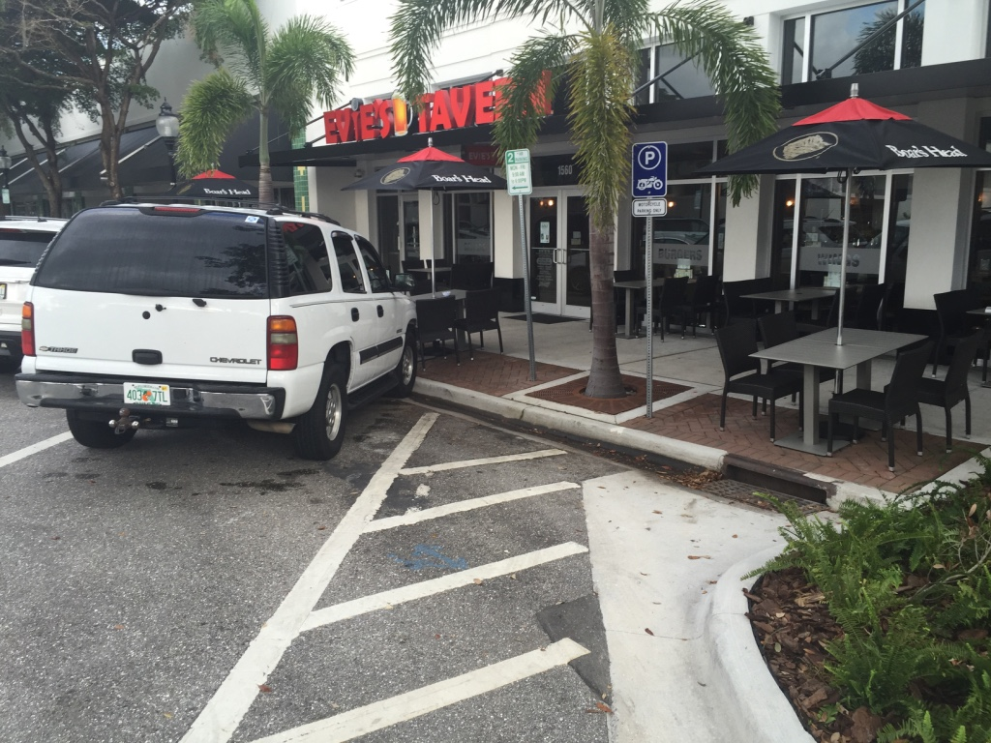
Photo 4: 1560 Main Street (legal parking space, yet painted with diagonal stripes)

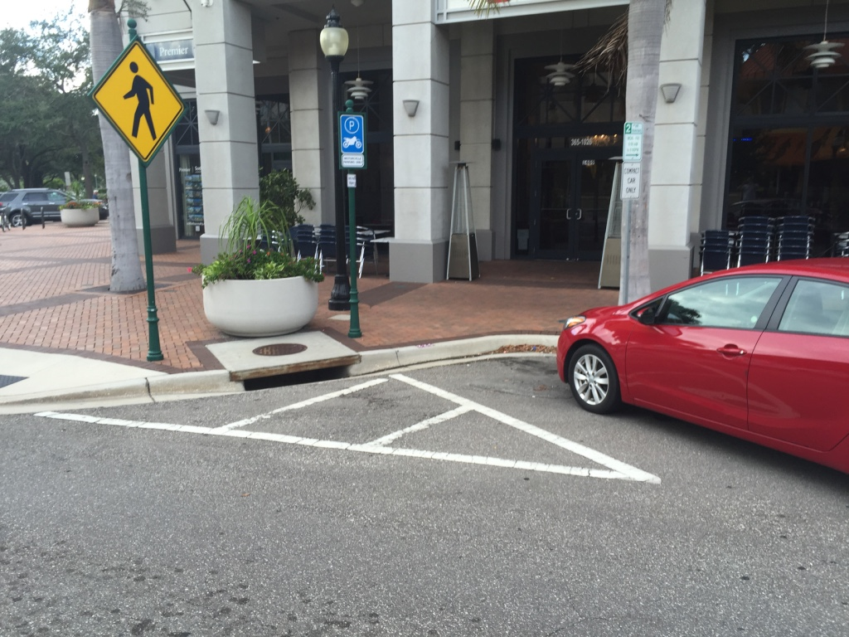
Photo 5: 1409 Main Street (legal parking space, yet painted with diagonal stripes)

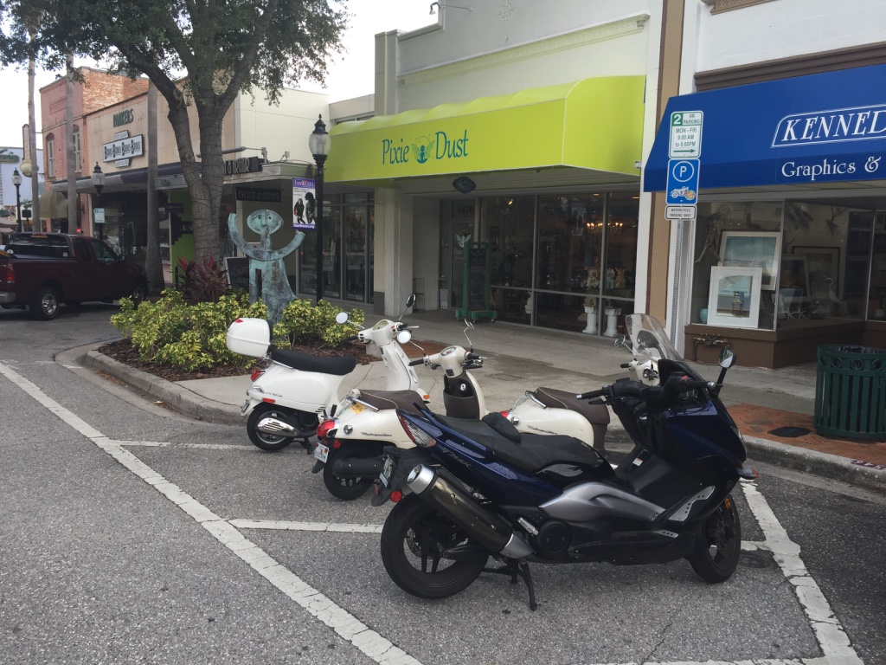
Photo 6: 1472 Main Street (legal parking space, yet painted with diagonal stripes)

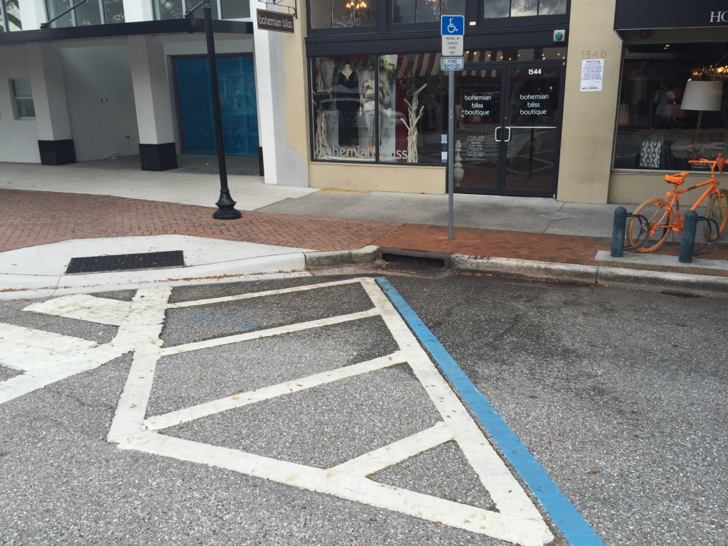
Photo 7: 1544 Main Street (typical handicap access aisle)

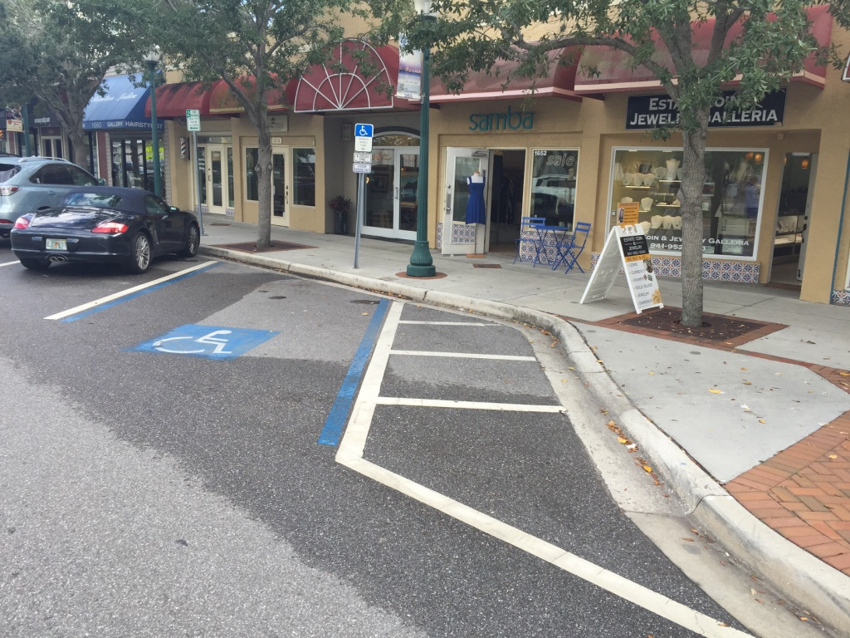
Photo 8: 1652 Main Street (typical handicap access aisle)

