On October 5 at 6:13 PM, my motorcycle was ticketed (copy of ticket is attached) for Sarasota Code Sec. 33-119 (“parked in a handicapped access space”) while parked in in front of 1453 Main Street. The fine for such an infraction is $250.00.

Parking Space Designation/Marking was Insufficient
Sarasota Code Sec. 33-119 is specifically pursuant to F.S. § 316.1955, which requires handicapped parking spaces to be “specially designated and marked.” More particularly, Sarasota Code Sec. 33-167 requires that spaces be “marked by the internationally accepted wheelchair, the caption 'PARKING BY DISABLED PERMIT ONLY', or both such symbol and caption.” However, rather than being “specially designated and marked” as required by 33-119, or marked by a symbol or a caption as required by 33-167, the space in which Defendant parked had no signage at all (see: Exhibit A, Photo 1).

Unlike the rest of the triangular parking areas on Main Street (see, e.g., 1507 Main at Exhibit A, Photo 2, and 1560 Main at Exhibit A, Photo 3), the triangular space at 1453 Main (see: Exhibit A, Photo 1) has no signage at all, nor any painted symbols, caption, or curb. In significant contrast to the rest of the Sarasota parking ordnances and Florida law, which require that all such prohibited parking spaces have signage indicating same, the indicated triangular areas in the 1400-1600 blocks of Main Street would seem to prohibit parking unless a parking-is-allowed sign is present.

Indeed, pursuant to Sec. 33-39, the City Engineer is authorized to prohibit the parking of vehicles, but must erect an “official signs” when doing so. The parking in front of 1453 Main is inconsistent with this requirement; namely, unlike the rest of the downtown areas where the City Engineer has erected signs to indicate places where parking is not allowed, at 1453 Main the motorist is expected to take the absence of such a sign as a prohibition on parking. This stands in stark contrast to both the letter and spirit of Sec. 33-39. This asymmetry in parking rules is more than a mere source of confusion, as it places an unfair burden on motorcyclists: first, to have advance knowledge of this unwritten rule, and second, it creates an affirmative duty to seek out parking spaces with signs which a parking-is-allowed sign. Similarly, this creates contradictory notice standards for motorcyclists (who would need to check for signs affirmatively indicating parking is allowed) and drivers (who must check for signs indicating parking is not allowed) .

Parking Space Status Remains Unclear
It has not been established that the space in which Defendant's vehicle was parked is even part of the access lane of the adjacent handicapped parking space. More specifically, the access lanes for all other handicapped parking spaces downtown have the same oblong configuration tangential to the parking space (see, e.g., 1544 Main at Exhibit B, Photo 1, and 1652 Main at Exhibit B, Photo 2; note that these are provided as examples only, as the access aisles for all the other handicapped spaces in the 1400-1600 blocks of Main are likewise oblong). Yet, in the case of 1453 Main (Exhibit B, Photo 3), there is a triangular area which has been bifurcated with a painted line separating the oblong area on the right (the standard access aisle) from the triangular region to the left which lay outside the aisle. It should be further noted that Defendant's motorcycle did not protrude into this access aisle, nor the handicapped space adjacent to it, nor did it obstruct the access lane or curb cut/ramp thereto.

Mitigating Circumstances
Assuming arguendo that the space Defendant occupied was indeed a handicapped access lane, and that the designation and notice provided was constitutional, the adjacent disabled parking space was occupied by a van when Defendant parked his motorcycle, such that any signage in front of said van was blocked. Defendant did not survey the signage of any adjacent parking spaces Defendant was not occupying, because Defendant was unaware of any imputed (and unprecedented) legal duty to do so.

Conclusion
For at least the reasons above, Defendant respectfully requests that this citation be dismissed.

EXHIBIT A

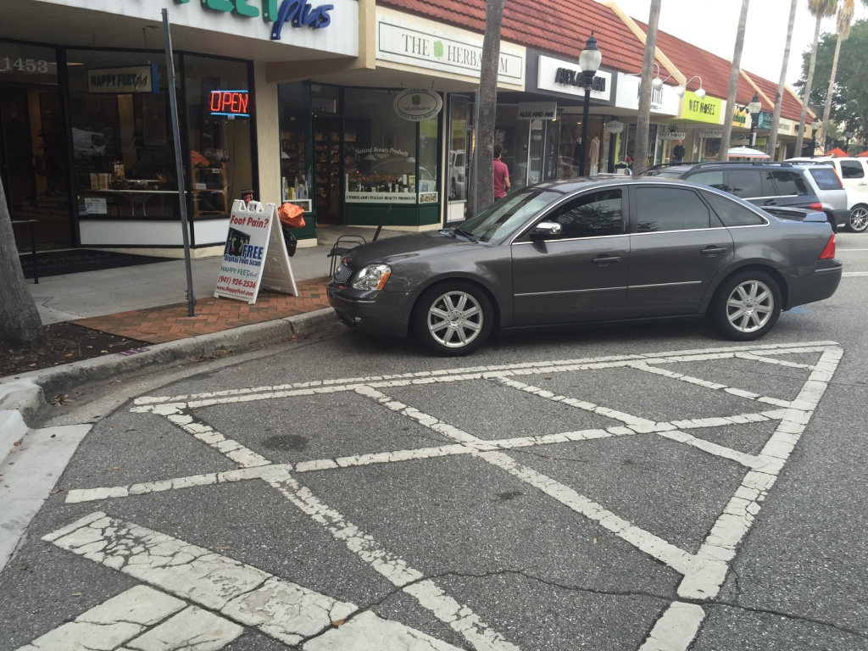
Photo 1: 1453 Main Street

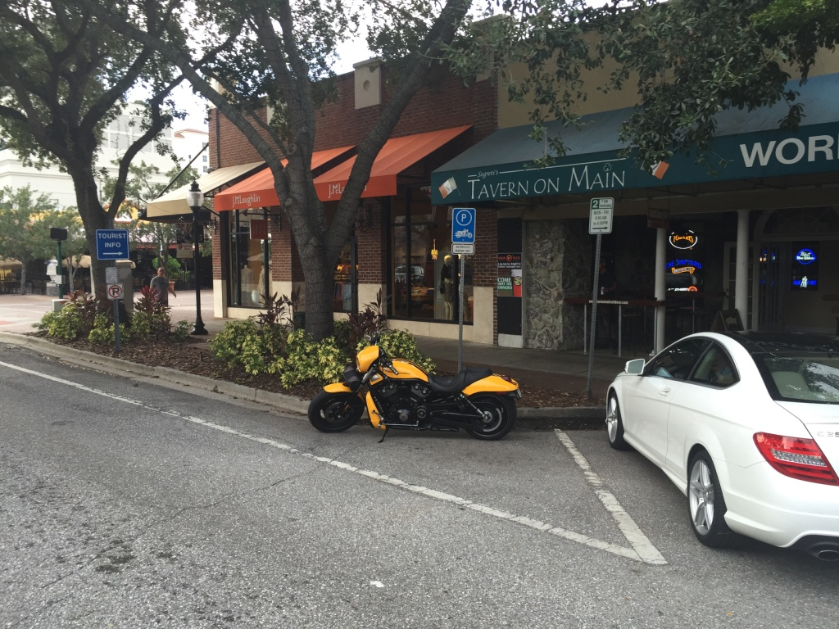
Photo 2: 1507 Main Street

EXHIBIT A (cont'd)

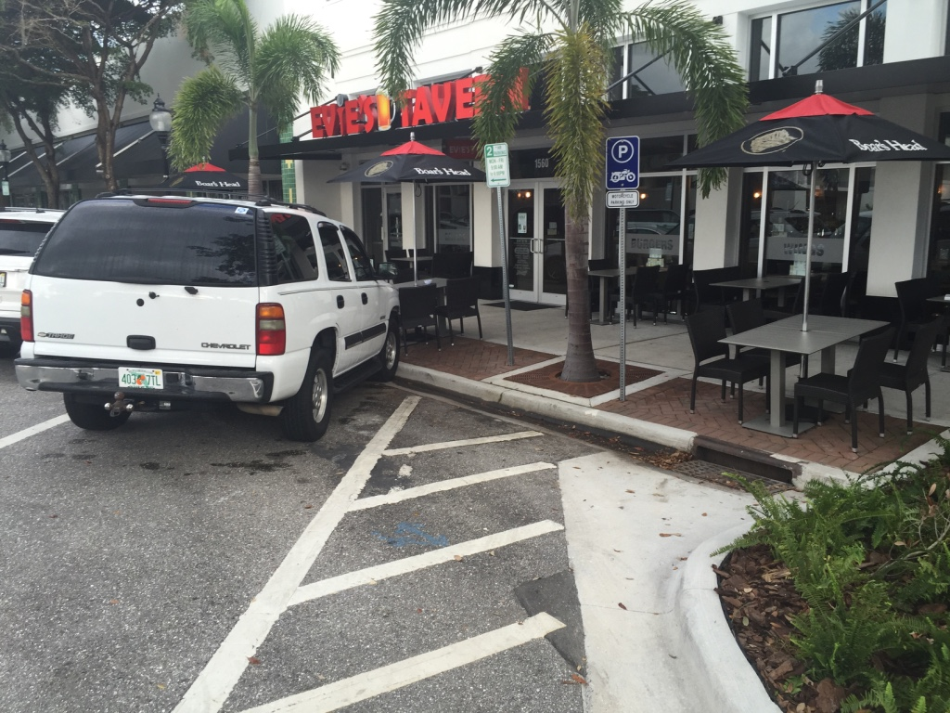
Photo 3: 1560 Main Street

EXHIBIT B

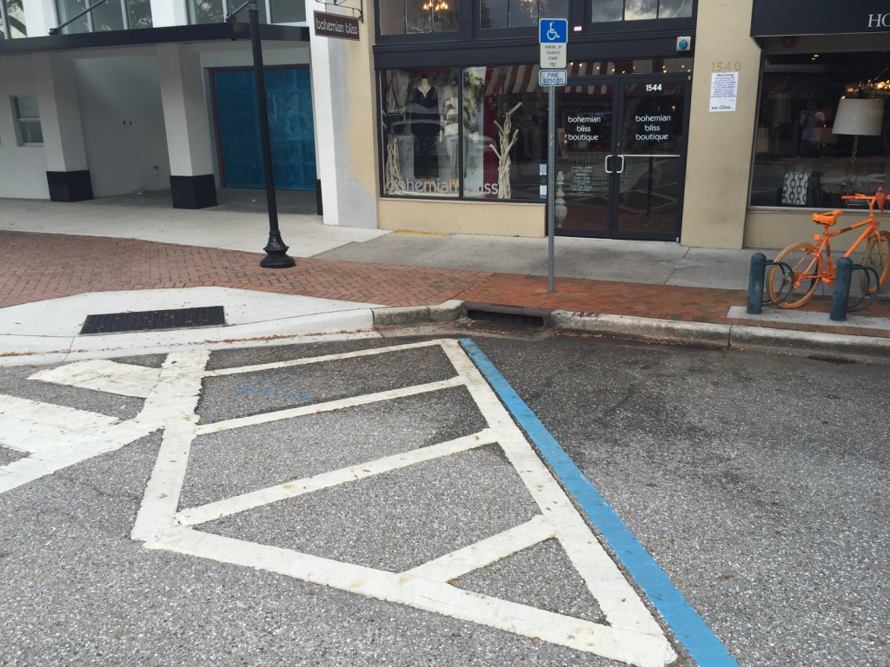
Photo 1: 1544 Main Street

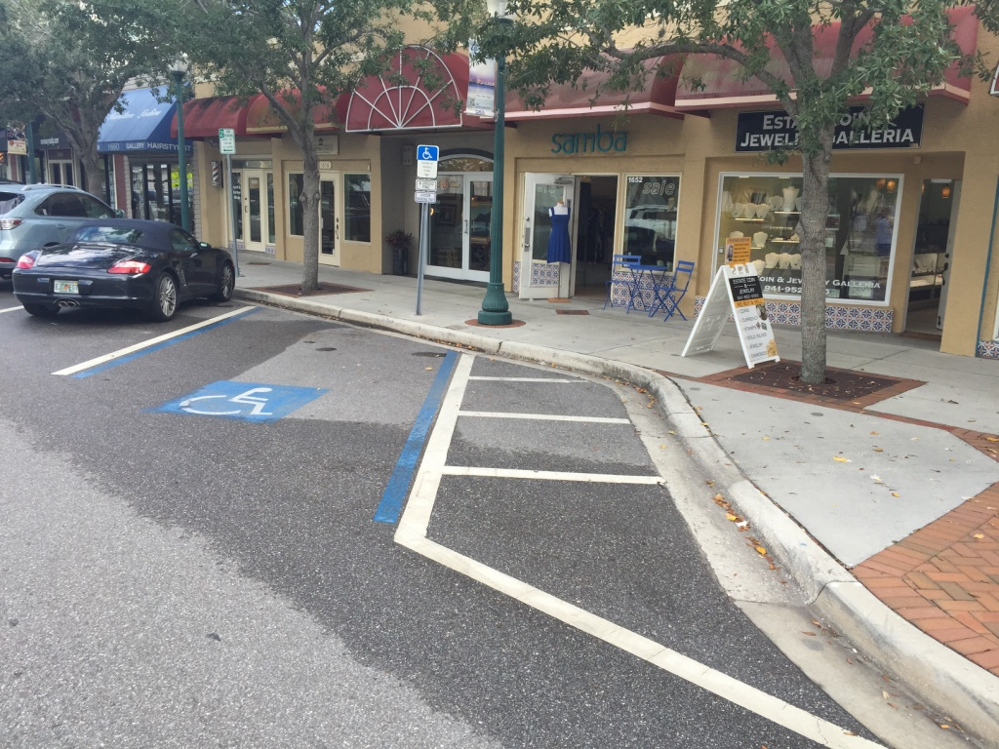
Photo 2: 1652 Main Street

EXHIBIT B (cont'd)

Photo 3: 1453 Main Street

